

Review Performance Feature Documentation

For HR

Table of Contents

1. Performance review flow and menu entries 1

1.1 Performance review flow 1

1.2 Menu entries and permissions 1

2. Reminder settings 3

2.1 Page permission 3

2.2 Permission to be reminding 4

2.3 Main page 4

3. Manage rating 6

3.1 Page permission 6

3.2 Main page 7

3.3 Add new score 7

3.4 Update score 8

3.5 Delete score 9

4. Manage criteria 10

4.1 Page permission 10

4.2 Main page 11

4.3 Create new criteria 11

4.4 Update and delete criteria 15

4.5 Approve criteria 16

5. Manage column template 18

5.1 Page permission 18

5.2 Main page 18

5.3 Create new column template 19

5.4 Clone column template 24

5.5 Approve column template 25

5.6 Update and delete column template 26

6. Manage templates 27

6.1 Page permission 27

6.2 Main page 28

6.3 Create a new template 28

6.4 Clone a template 30

6.5 Create a section 31

6.6 Create subsections 38

6.7 Set up criteria 44

6.8 Update and delete a section 47

6.9 Update and delete template 49

6.10 Approve and reject template 50

6.11 Set up rating details 52

7. Manage forms 54

7.1 Page permission 54

7.2 Main page 54

7.3 Create new form 54

7.4 Add members to form 54

7.5 Review members 54

7.6 Reject and complete form 54

# Performance review flow and menu entries

## Performance review flow

// TODO

## Menu entries and permissions

* The feature has 6 entries in total.

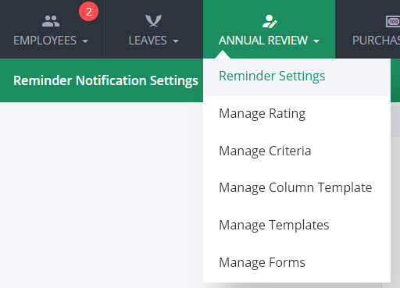

* Parent menu entry “**Annual Review**” only appears when current user has permission to, at least, one of its children.
* Permissions of this feature can be found at “**ReviewPerformance**” module in any user group from “**Authority** → **Group Permissions**”.
* Click on “**Group Permissions**”

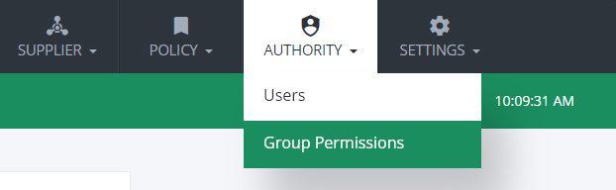

**1**

* Click on “**edit**”  button on any user group.

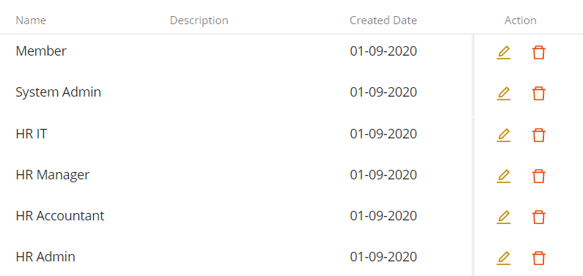

**1**

**2**

* Then check on any “**View**” permissions you want to allow.

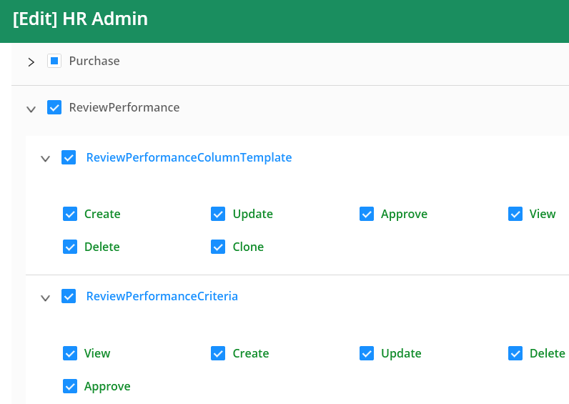

**2**

**3**

**3**

# Reminder settings

## Page permission

* This page need permission “**View**” in “**ReviewPerformanceReminderSetting**”.

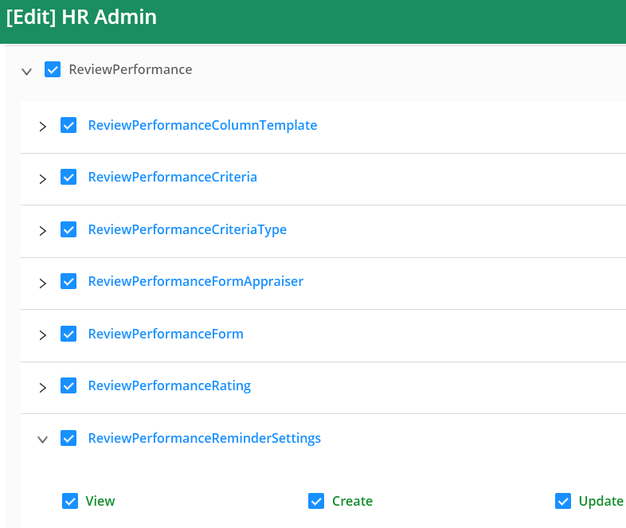

* After enabling, “**Reminder Settings**” will appear.



## Permission to be reminding

* These settings will remind employees who have “**Update Form Members**” permission from “**ReviewPerformanceForm**”.

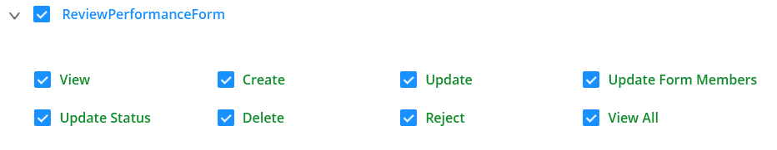

## Main page

* This place is where you can setup time to remind people who have related permission (see above).
* Hover to the icon  for more information or see explanations below.
* **Note**: for the sake of simplicity, the phrase “employees who have permission to create review performance form” will be refered as “HR”.

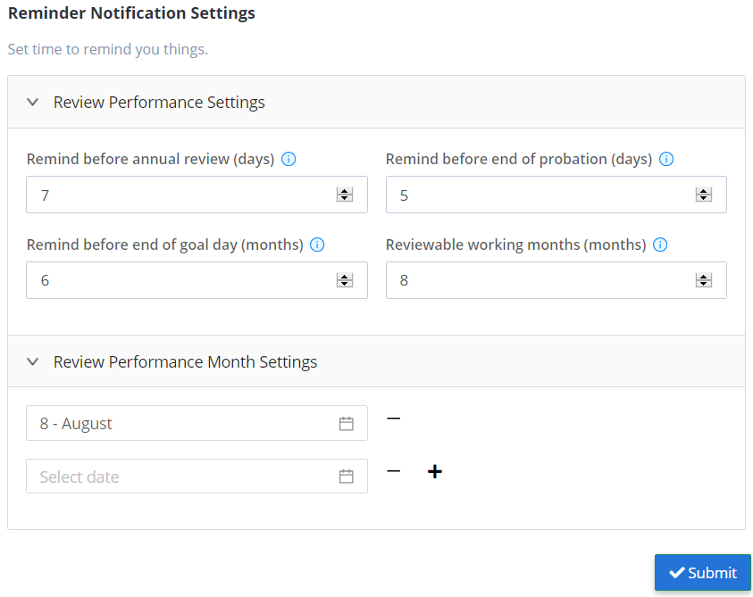

* “Remind before annual review (days)” means the system will send notifications and emails to HR before annual review performance period a number of days. The system will automatically create annual review forms for reviewable employees. This options will trigger once before every month in “Review Performance Month Settings”.
* “Remind before end of probation (days)” means the system will send notifications and emails to HR before probation review performance period a number of days if there is at least one employee who is about to reach the end of their probation and at least one approved probation template.
* “Remind before end of goal day (month)” means the system will send notifications and emails to employees once every a number of months to remind them their SMART goals.
* “Reviewable working months (month)” means only employees who has worked for company for a number of months can be reviewed in annual review, probation period included. This option only affect the annual review form auto creation (see “Remind before annual review (days)”).
* “Review Performance Month Settings” allows you to set up months to remind annual review. This option affect “Remind before annual review (days).

# Manage rating

## Page permission

* This page needs permission “**View**” in “**ReviewPerformanceRating**”.

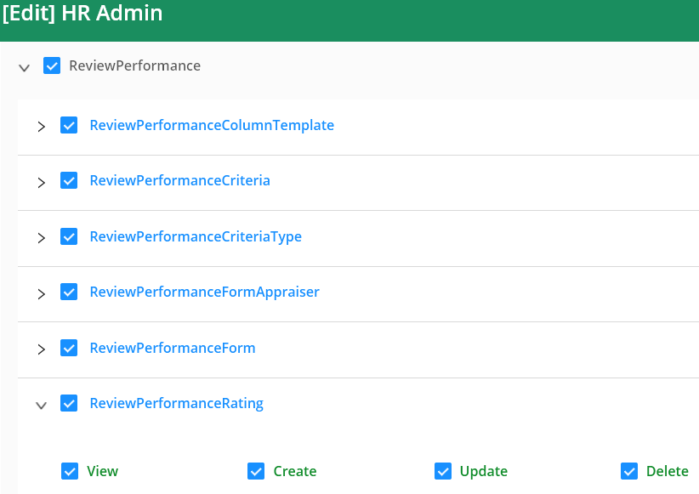

* After enabling, “**Manage Rating**” menu entry will appear.



## Main page

* This page is where you define the set of scores and map score ranges to score texts or score letters.

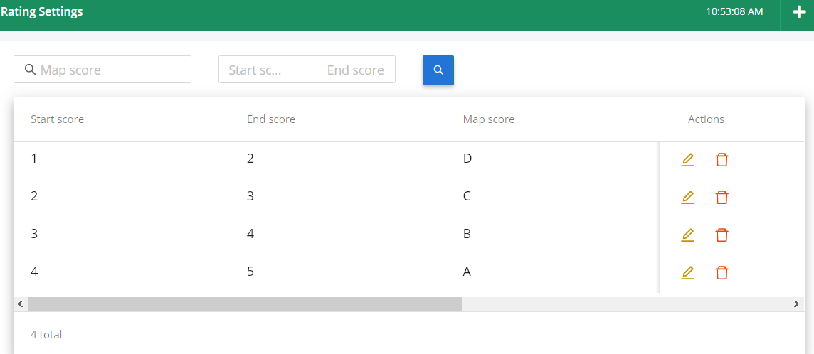

* There is only **one** set, and score ranges must not be overlaping each others.
* **Rule**: the score range - “**Start score**” and “**End score**” pair, contains all values which are greater or equal to “**Start score**” and less than “**End score**”. For example: score “**2.3**” will be mapped to score “**C**”, but, “**3**” will be mapped to score “**B**”.

## Add new score

* To add new score range, click the plus shape button on the top right corner and the pop up will appear.



* Then enter the “**Start score**”, “**End score**” and “**Map score**”. The new score range must not overlap other score ranges (see “**Rule**” from section “3.2”).

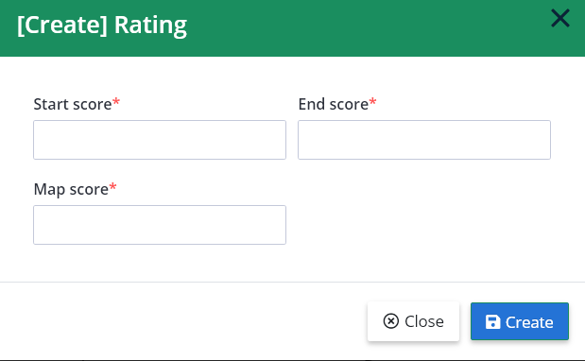

* For example: if you try to enter “**Start score**” to **1** and, “**End score**” to **3**, with whatever “Map score” (we use “**Z**” for this case). Click “**Create**”, then an notification will pop up to show the error because we overlap the new score with current score ”**D**”.

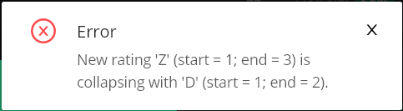

## Update score

* To update score, click the icon edit  on a row in the main page.
* A pop up appears and automatically fills current score data. For example, click on edit score “**D**”, the following pop up will appear.

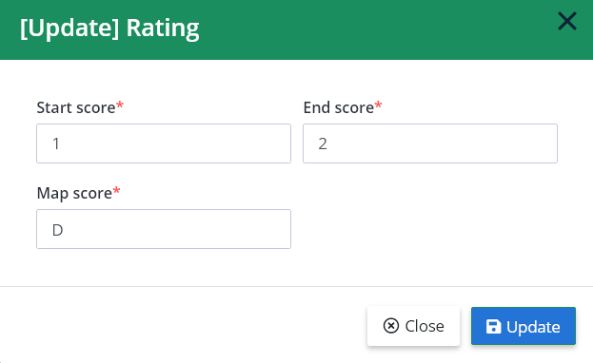

* The “**Update**” pop up behavior is just like the “**Create**” pop up, with same rule. This allows you to shrink, expand or even put current score range/rating to completely new place as long as it doesn’t violate the rule (see “**Rule**” from section “3.2”).

## Delete score

* Click on delete  icon and click “**OK**” to confirm action.

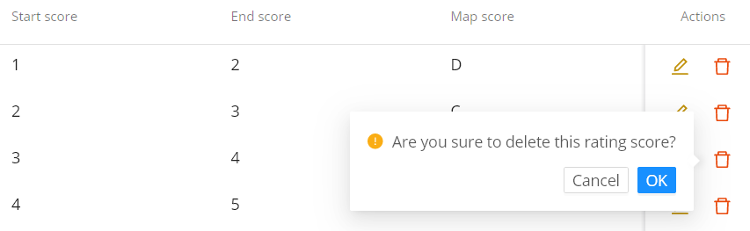

**2**

**1**

* Ratings/scores *shouldn’t* be updated/deleted frequently, since they can affect other activities like when appraisee trying to fill their review performance form - rating themselves and suddenly, the ratings/scores doesn’t exist anymore. This leads to bad data.

# Manage criteria

## Page permission

* This page need “**View**” permission in “**ReviewPerformanceCriteria**”.

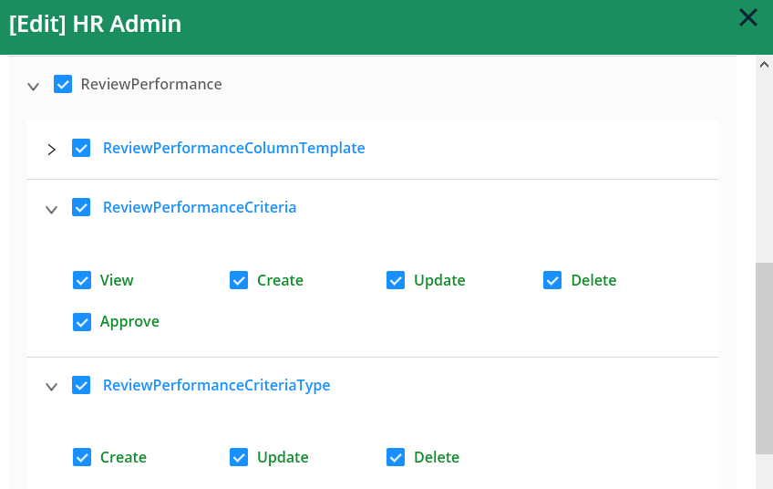

* Then the menu entry will appear.



* Those permissions in “**ReviewPerformanceCriteriaType**”: “**Create**”, “**Update**” and “**Delete**” only apply for reating, updating and deleting root criteria titles and their display styles (see 4.2).
* Those permissions in “**ReviewPerformanceCriteria**”: “**Create**”, “**Update**”, “**Delete**” and “**Approve**” only apply for current selected root criterion (see 4.2).

## Main page

* Main page is split into two parts: the left works like a list of tabs displaying root criteria; the right list all criteria of current selected root criterion.
* Below image shows a snippet of “Performance Skill” criterion children. Its criteria has already been approved, so the texts are green and only the view buttons  appear.

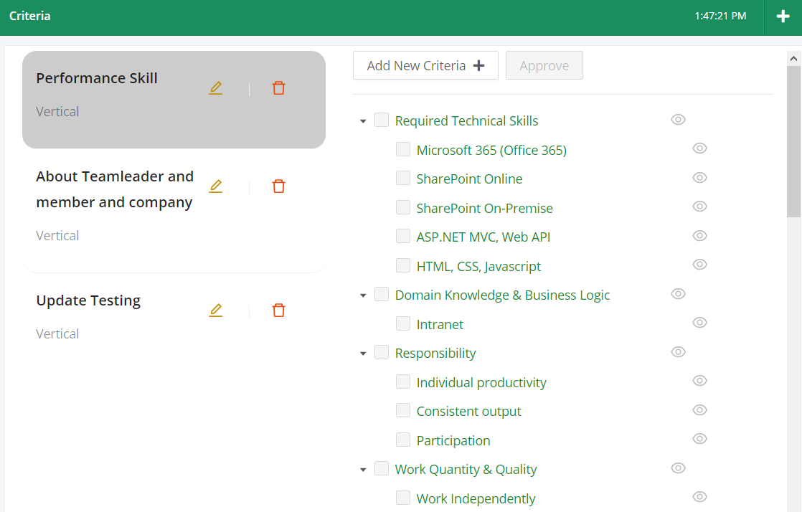

* Defining criteria is defining a set of columns which is based on “max criteria level” (see “max criteria level” in section 4.3).

## Create new criteria

* To create new root criteria, click the plus sign button on the top right corner.



* The pop up to fill information will appear, see below. The “**Title**” is empty and required, while “**Display type**” is set default to “**Vertical**”. Then click “**Create**” to save.

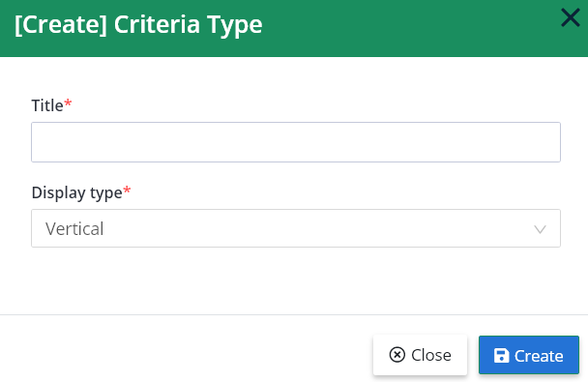

* There are two display types: “**Vertical**” and “**Horizontal**”. They are refered to the way criterion’s title displayed when they are rendered on the review form. “**Vertical**” is displayed rightward (left to right), like normal texts; “**Horizontal**” is displayed bottom-up (bottom to top) like the column “**Subject**” in the image below (this image is cut from the old review form from a blank review excel file).

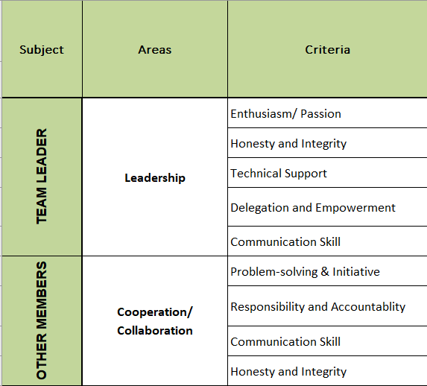

* To create children criteria, we need a root criterion. For this example, we created a new root criterion with title “Root criterion” and display style is “**Vertical**”. You can create children criteria for approved root criteria (as long as they hasn’t been used in any template yet, see 4.54.4).
* After creating, a new entry “Root criterion” will appear at the end of the list. Then click on it to start working.

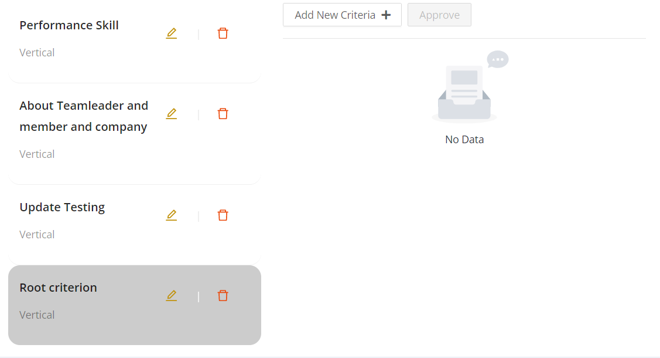

* Then click on “**Add New Criteria +**” button, a pop up will appear. This pop up modal is identical to the pop up when you were creating “Root criterion” and it behaviors are exactly the same. Typing “Criterion 1” and click “**Save**”.

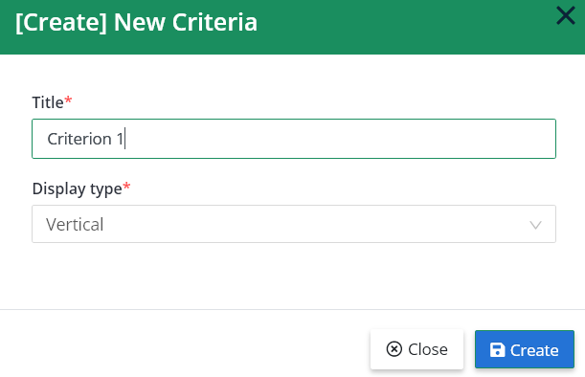

* After saving, a new entry “Criterion 1” on ther right will appear.

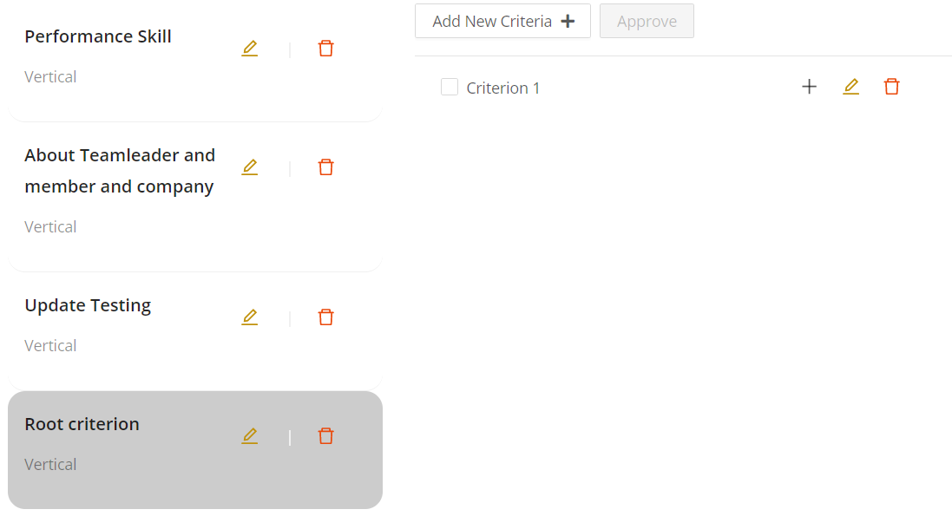

* Each children criteria has three buttons to create , update  and delete , which are corresponding to “**Create**”, “**Update**” and “**Delete**” permisison in “**ReviewPerformanceCriteriaType**” (see 4.1).
* Clicking on  button to create next level criterion child (in current context, it is level 2), the pop up will appear and just like the step to create root criteria (see above).
* “Max criteria level” is the max depth of a criteria tree. For example: “Performance Skill” has max criteria level is **2**, but “About Teamleader and member and company” has max criteria level **3** (note that the number couting max depth of these trees).

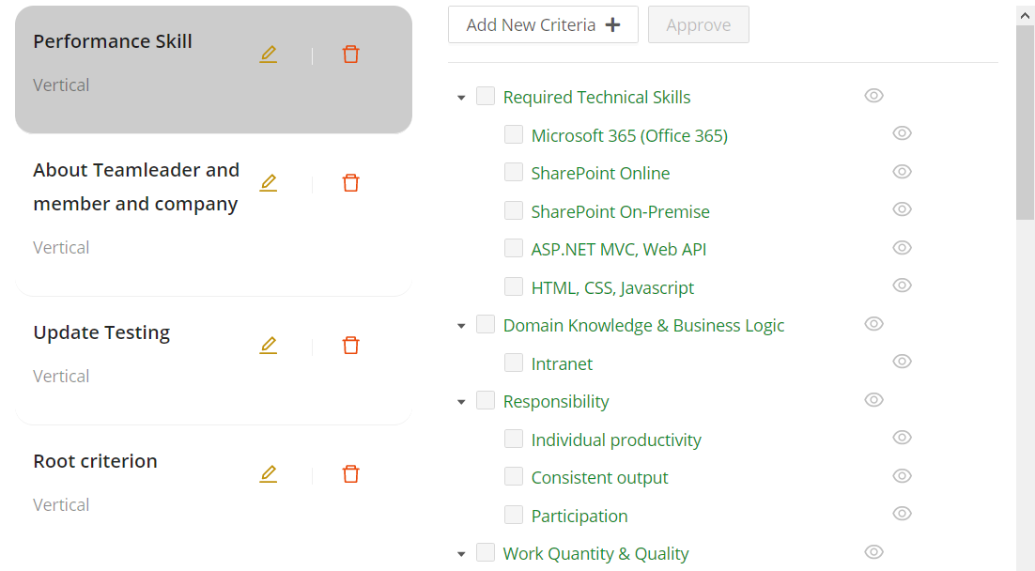

**2**

**1**

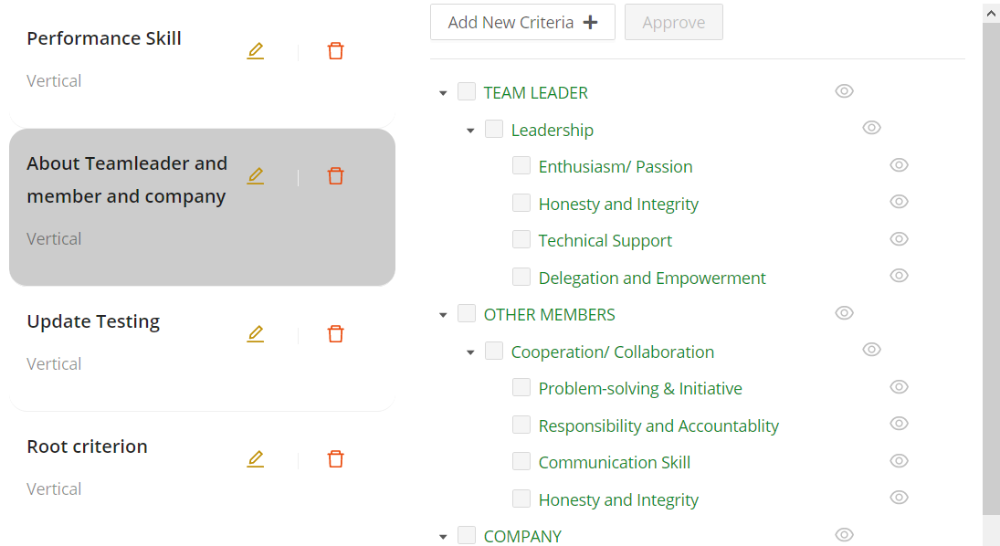

**3**

**2**

**1**

* “Max criteria level” is important. When creating column template, the system will use “max criteria level” of each criteria to generate number of columns respectively.

## Update and delete criteria

* If current user has related permissions (see 4.1) update  and delete  buttons will appear corresponding to their permissions.



* As long as the criterion hasn’t been approved, they are able to edit and delete freely.
* If they are already approved, the textes are green and only the view buttons  appear. (see 4.2).
* When click on the update  button, a pop up will appear. This pop up is idetical to “create” pop up, except that it operates on current updating criterion. After making changes, click “**Update**” to save changes.

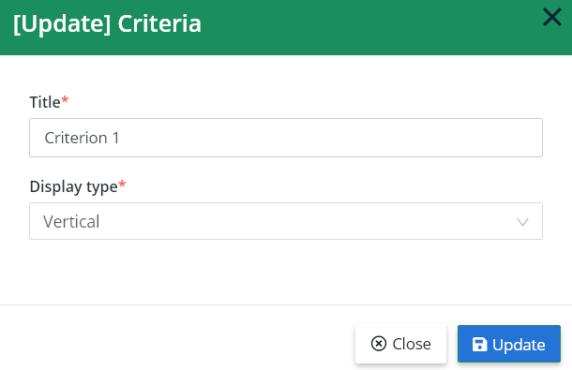

* To delete a criterion (include root criterion), simply click delete  button, a small pop up will appear to ask for confirmation. Then click “**OK**” to confirm.

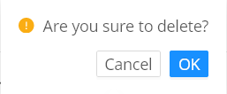

* A root criteria can only be deleted when it contains no criteria.

## Approve criteria

* To approve criteria, check all criteria you want to approve, then click “**Approve**” button. The button only appears when current user has “**Approve**” permission (see 4.1).

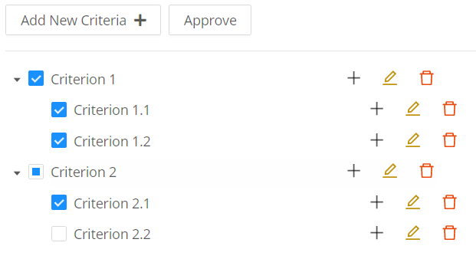

**2**

**1**

* After approving, all the checked criteria texts will turn green and editable buttons will disappear.

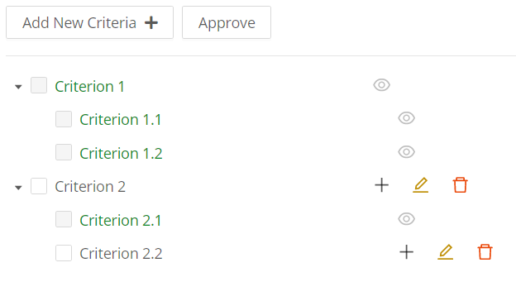

* Approved criteria can’t be edited and add new child criterion.
* All other users who has “**Approve**” permissions will be notified by notifications and emails when criteria have been approved.
* Only approved criteria are available to be picked in column template and selected in review form.

# Manage column template

## Page permission

* This page needs “**View**” permission in “**ReviewPerformanceColumnTemplate**”.

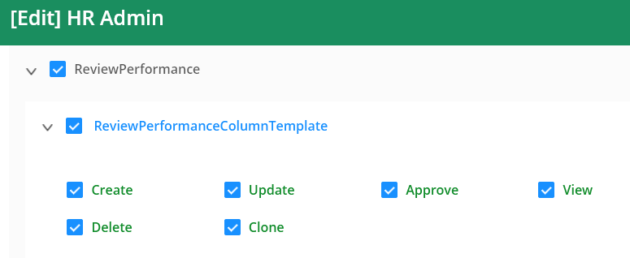

* After enabling it, “Manage Column Template” menu entry will appear.



* Other permissions: “**Create**”, “**Update**”, “**Approve**”, “**Delete**” and “**Clone**” allow you to make changes on a column template. Especially, “**Update**”, “**Approve**” and “**Delete**” are only operable on column templates which has not been approved.
* Users who have “**Approve**” permission can approve column templates and will be notified when a column template is approved.

## Main page

* Main page is split into two parts: left part displays a list of column templates and buttons to operates on those column templates, right part displays columns of current selected column template and their details.

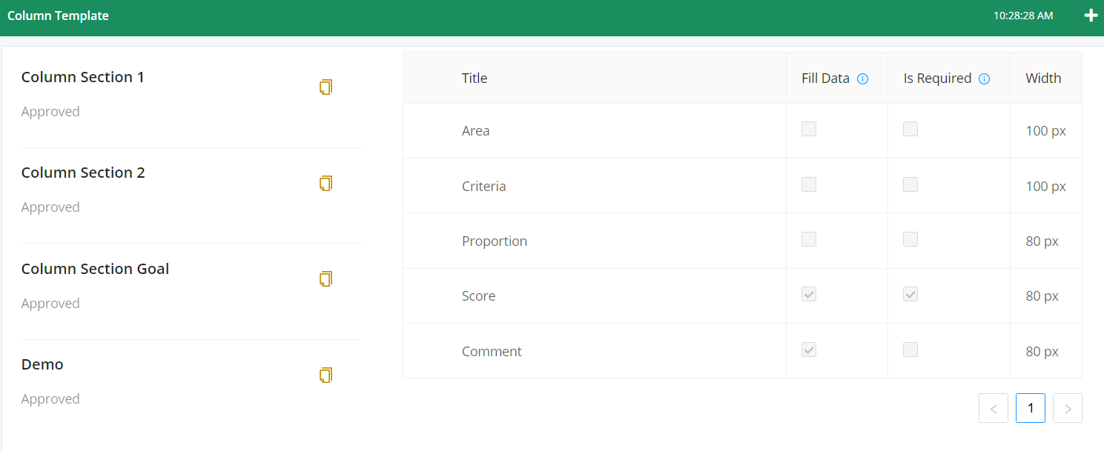

* A column template defines the layout of a review form section. For example, the image above is define the layout of these columns from old review form from an excel file . Notice the similar titles from two images and please ignore “By Leader”, “By EE”, … columns. We will go through that in 5.3.

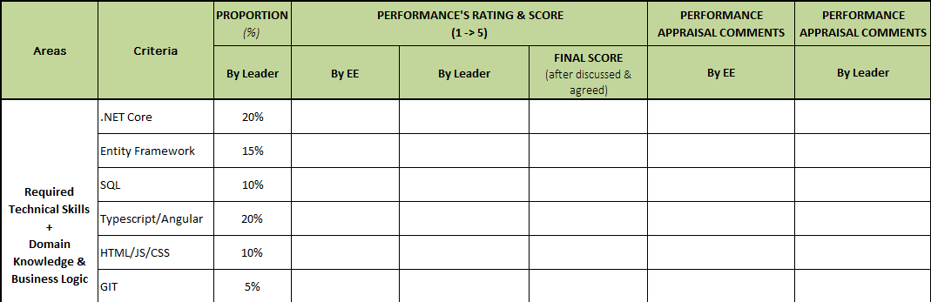

* Some fields don’t show enough information, they will have a small icon  next to their titles (see the first image of this section). Hover over that icon and a tooltip will appear to show what it is for.
* “Fill Data” means this column only display input when reviewing.
* “Is Required” means this column must be filled before submitting – when appraisers or appraisees fill information.

## Create new column template

* To create a new column template, click the plus button on the top right corner and a pop up will appear.



* The creating column template pop up contains just only a field for title – this field is required. Typing title and click “**Save**” to finish.

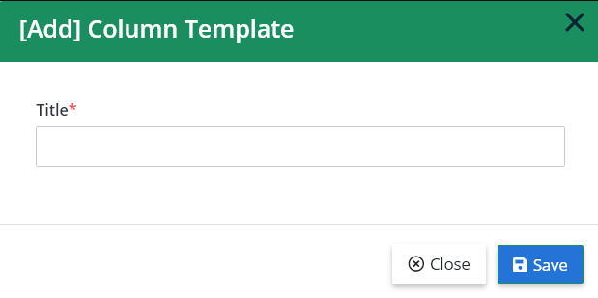

* For example, we are going to recreate column layout from 5.2. The layout looks like this:



* First, we need to create a new column template, we name it “Column section A” (please don’t mind the name). After creating, a new entry appears at the end of the list on the left, click on it to start working. The result will look like this:

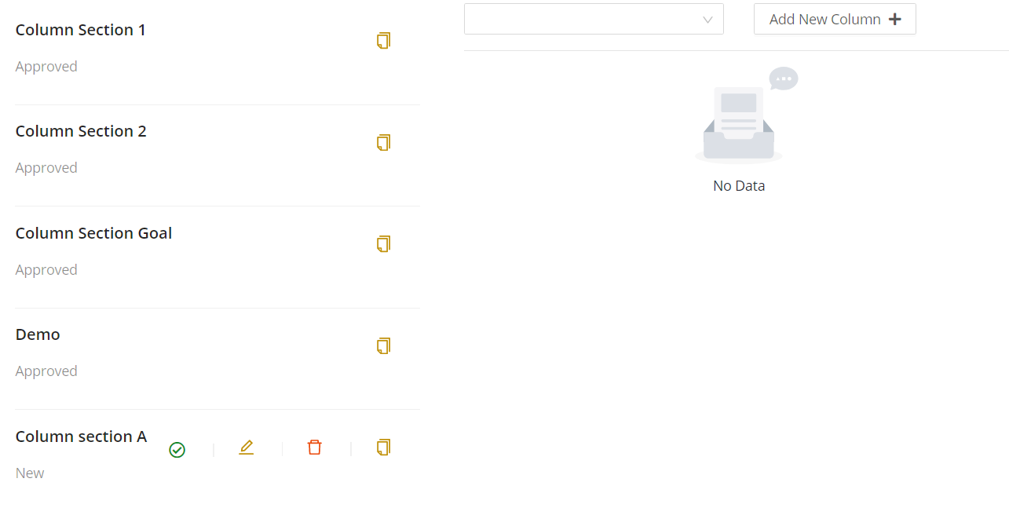

* After creating new column template successfully, we are going to add columns. To do this, pick each approriate column in the dropdown box on top of the right side and click “**Add New Column +**”.

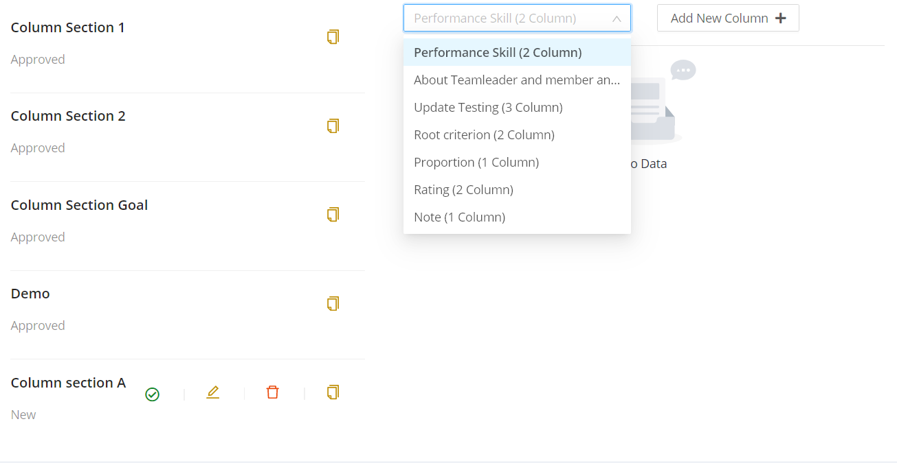

**1**

**2**

* **Note**: all the columns in the dropdown box are approved criteria from section 4, and the text “(2 Column)” is the “max criteria level” of that root criterion (see “max criteria level” in 4.3). Other columns “Proportion”, “Rating” and “Note” are special system built-in columns. Adding the same criteria more than one time is not allowed, only system built-in columns can be added more than one time.
* **Note**: system built-in columns have special functions:

“Rating” has two columns: one for “score” and one for “comment” and it will generate a pair of columns for each appraisers and appraisee.

“Proportion” has one column and it defines the percentage of each row in section. This will affect the overall score for that section.

“Note” has one column and typically uses for storing notes.

* For this demonstration, we need “Performance Skill”, “Proportion” and “Rating”. By adding one by one, the result looks like this:

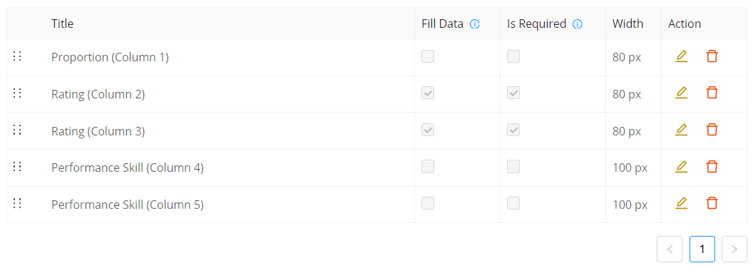

* Those checks and width values were default value of that column. To change them, click the edit button .
* Proportion column define percentages, and it absolutely needs to be filled before reviewing, so it must be not “Fill Data” and not “Is Required” because only HR and appraisers can fill all information before reviewing. We also rename it to just “Proportion”. Then click save button  to save changes, or cancel button  to abort changes.

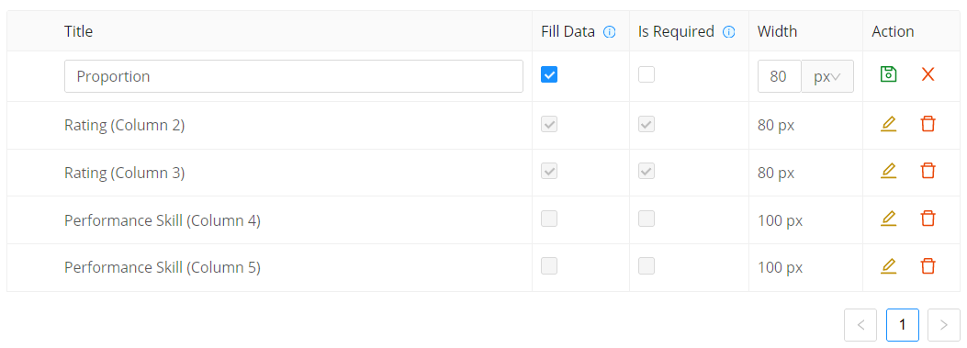

* The “Width” column determines the width of that column when rendering the review form. This setting is allowed to change even after the column template approved. Its has two options, “px” or “%” means the current width is in pixel or percentage of section table.
* Make changes other columns:

“Rating (Column 2)” into “Score”, and this column is required appraisee rating themselves, and appraisers rating appraisee. Check “Fill Data” and check “Is Required” because it only needs data when reviewing.

“Rating (Column 3)” into “Comment”, check “Fill Data” and check “Is Required”, this column depends on appraisers/appraisee’s comments are mandatory or not, if not, uncheck “Is Required”.

“Performance Skill (Column 4)” into “Area”, because criteria must be filled before reviewing uncheck “Fill Data” and appraisee can’t choose criteria anyways, so uncheck “Is Required”.

“Performance Skill (Column 5)” into “Criteria”, uncheck “Fill Data” and uncheck “Is Required”, reasons are the same as above.

* After saving all changes, the result looks like this:

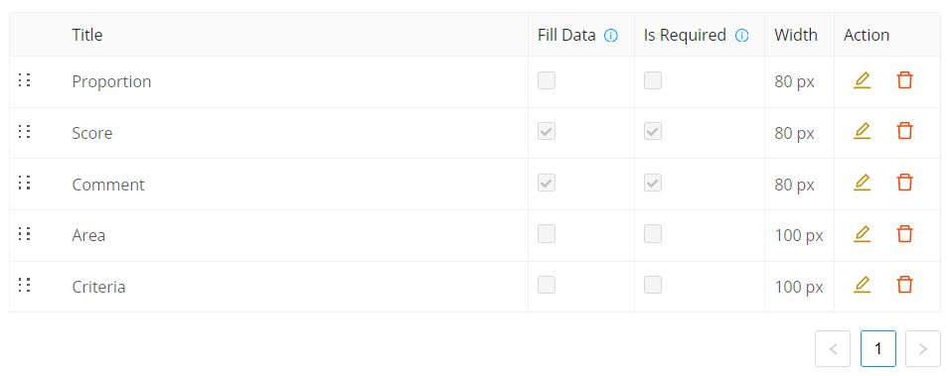

* Next, we have to change position of “Area” and “Criteria” columns by hold left click on the 6-dots next to the title and drag it to the top. Change “Area” position will also change “Criteria” position. See “**Note**” below.

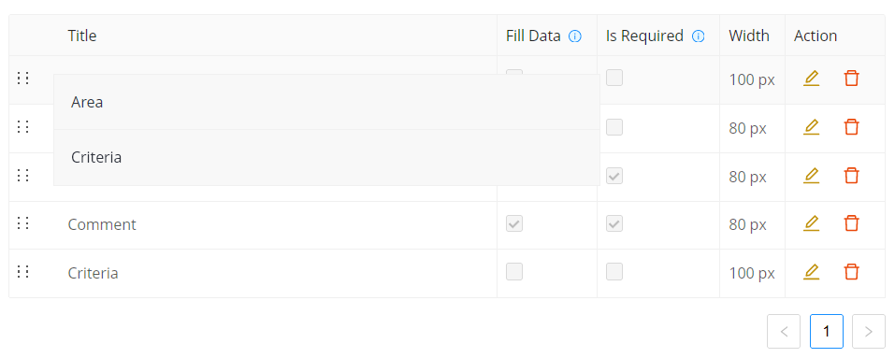

* The result looks like this:

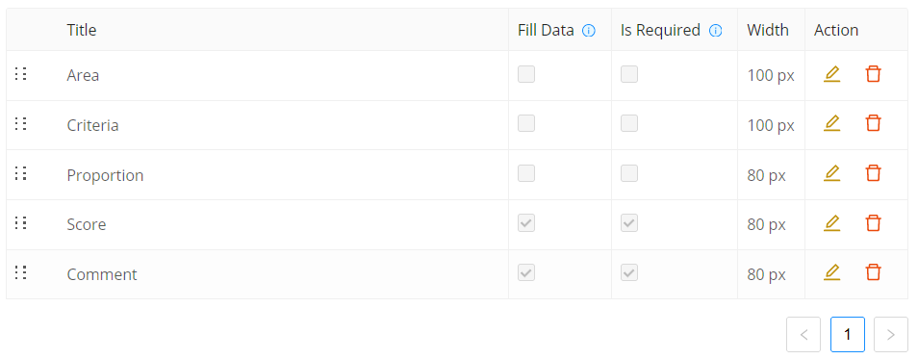

* To delete a column, click delete button , a pop up will appear to ask for confirmation, then click “**OK**” to confirm.

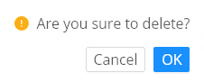

* **Note**: columns will go in a set, which means making changes to their positions or delete one of their column will delete the others in that set. For example, if you delete “Criteria”, then system will delete “Area” column as well.

## Clone column template

* Cloning column template is useful for creating new version of column template based on the older one. Cloning column template will create a new column template with the same name.
* To clone a column template, click clone button , a pop up will appear for confirmation, then click “**OK**” to confirm.

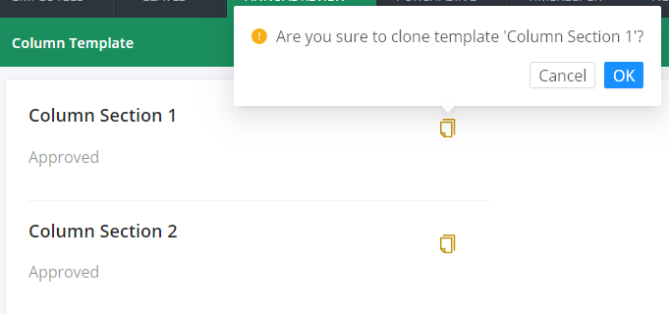

**2**

**1**

* For example, we will clone “Column section 1”, the result looks like this:

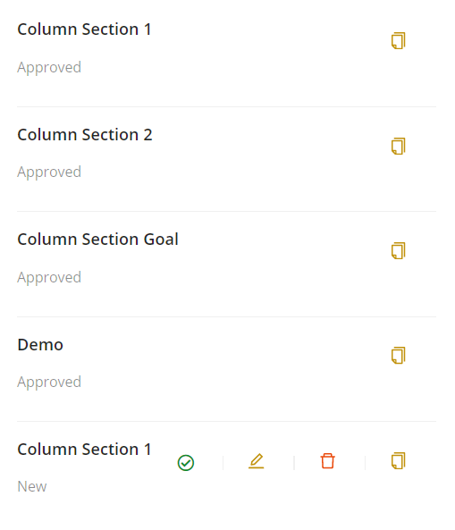

## Approve column template

* “Approve a column template” means that the column template will be available for using in making review form template and can’t be edited or deleted anymore.
* To approve, click on approve button  and then click “**OK**” to confirm approval.

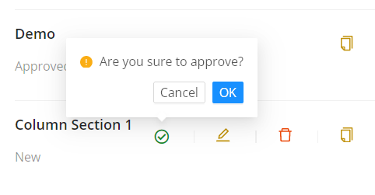

**2**

**1**

* Approving a column template also notify other employees who have “**Approve**” permisison (see 5.1).

## Update and delete column template

* To update a column template, click on edit button , type new title then click “**OK**” to save.

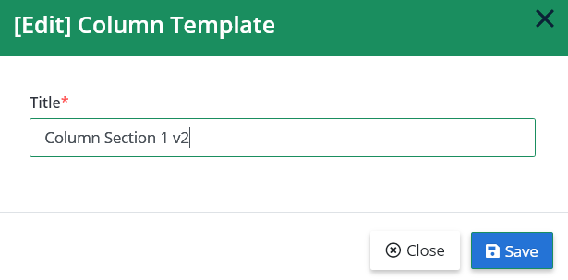

* To delete a column template, click on delete button  then click “**OK**” to confirm.

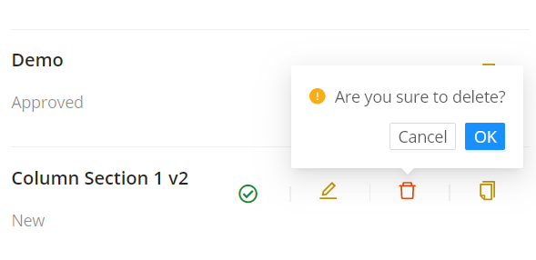

**1**

**2**

# Manage templates

## Page permission

* This page need “**View**” permission from “**ReviewPerformanceTemplate**”.

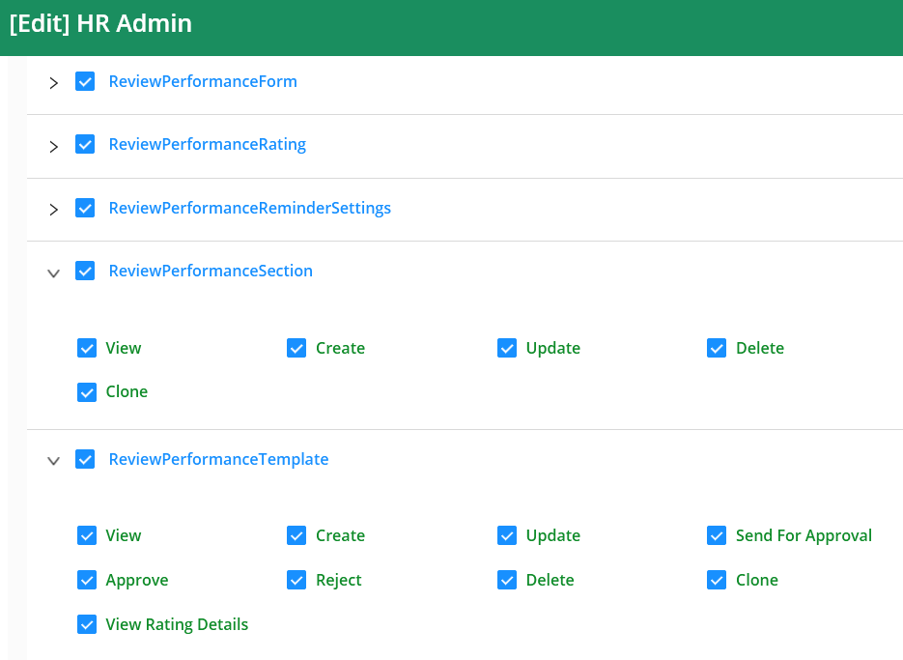

* After enabling, “**Manage Templates**” entry will appear.



* To set up a template, we need permissions from both “**ReviewPerformanceTemplate**” and “**ReviewPerformanceSection**”.
* “**ReviewPerformanceTemplate**” contains permissions to work on template like “**Create**”, “**Update**”, “**Delete**” and “**Clone**”. Others are “**Send For Approval**”, “**Approve**”, “**Reject**” to decide if a template is qualified to use in review performance period. “**View Rating Details**” permission is for setting up rating guideline for each score in each criterion.
* “**ReviewPerformanceSection**” contains permission to work on setting up sections “**View**”, “**Create**”, “**Update**”, “**Delete**” and “**Clone**”. All sections are set up in template page.

## Main page

* Main page is split into two parts: left part displays a list of templates and buttons to operates on those templates, right part is working space setting up sections in current selected template.

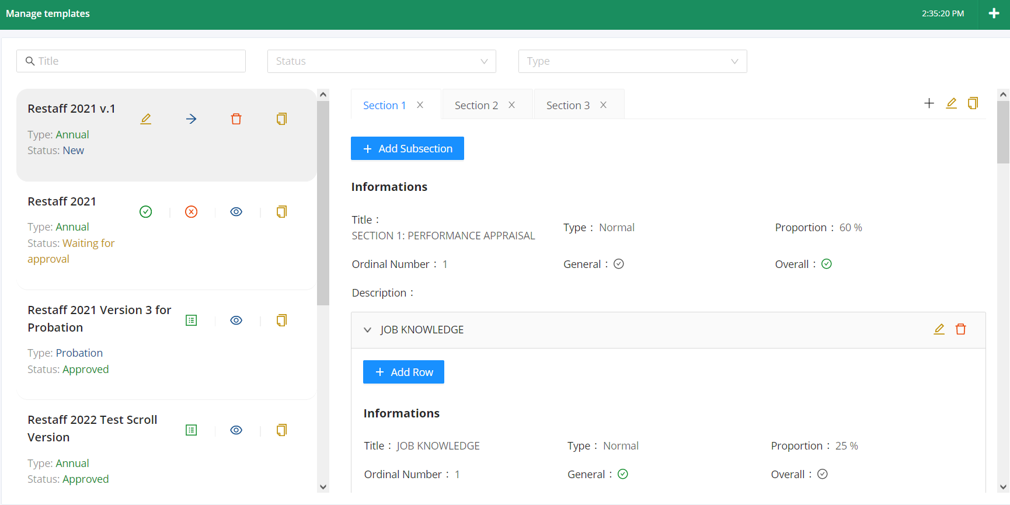

* Only template with status new can be edited.

## Create a new template

* To create new template, click the add button on the top right corner and a pop up appear.



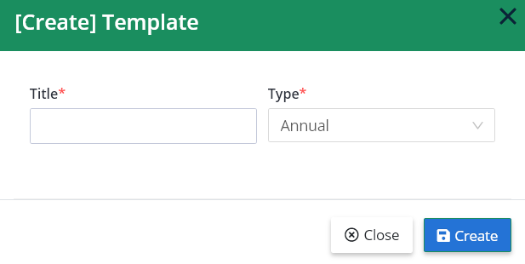

* Type in the name of the template in “Title” and select the type of template then click “**Create**” to create template.
* There are three types of template: “Annual”, “Probation” and “Exceptional”. Template type “Annual” is for performance review on offical employees. Template type “Probation” is for employees who is about to end their probationary period. Template type “Exceptional” is for urgent or unexpected performance review.
* For example, we will create a template “Performance Review Restaff 2021” with type “Annual”. After creating the new template appears on top, the list looks like this.

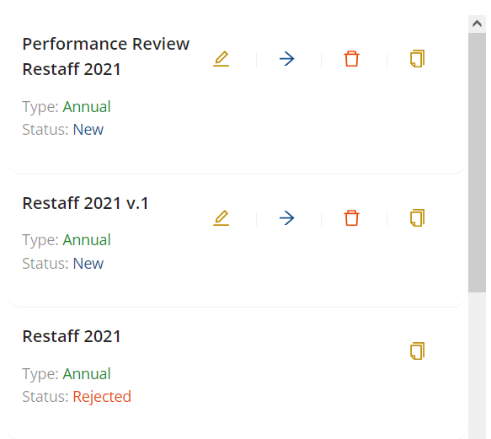

* After creating, click on the new template to start setting up its sections.

## Clone a template

* To clone a template, simply click the clone button , a pop up will appear, then click “**OK**” to confirm.

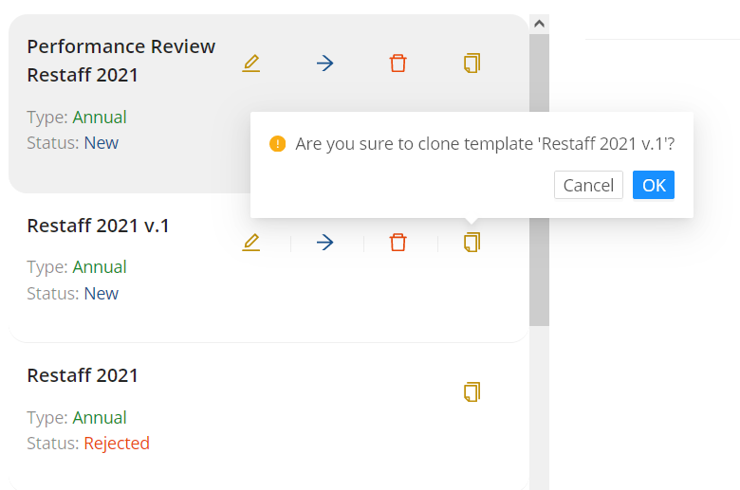

**2**

**1**

* After confirmation, a new template with the same name and has status “New” will be created and will be on top of the list. The clone feature is convenient for create a new version of approved or rejected template based on those template.

## Create a section

* Click on the template to start setting up sections. Then click the add button  to create a new section.

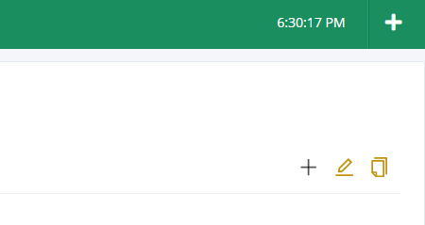

* A pop up will appear to fill in information. All the fields marked with red star are required fields. For explanations, see below.

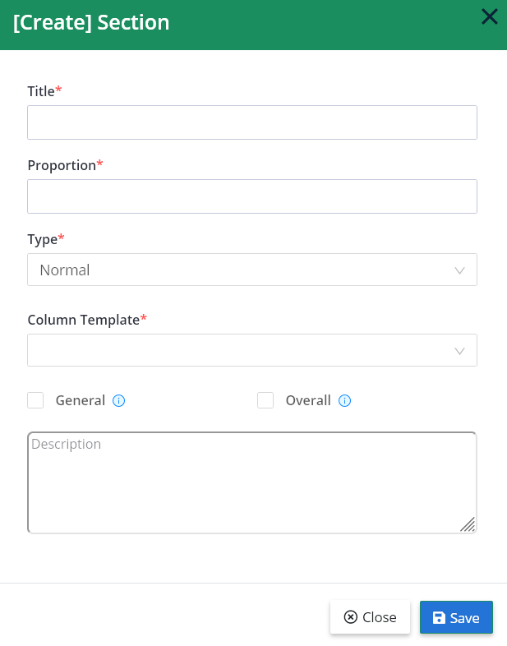

* “Title” field contains section name.
* “Proportion” field contains current section proportion, total proportions of current section and its siblings must be 100%.
* “Type” field defines current section type. There are two types of section: “Normal” and “Goal”. Type “Normal” means that current section is a normal section where the appraisers and the appraisee will rate and comment, while type “Goal” is where the appraisee creates plans for their goals. Hover into  icon for more information.

Default section type is “Normal”.

Current “Goal” section type is S.M.A.R.T goal type. This section type will goes along with “Column Section Goal” in “Column Template”.

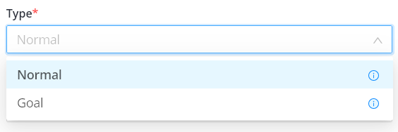

* “Column Template” field defines current section column layout. Only approved column template will appear in this list (see 5.5 to read about approving column template).

“Column Section Goal” typically goes along with section type “Goal”.

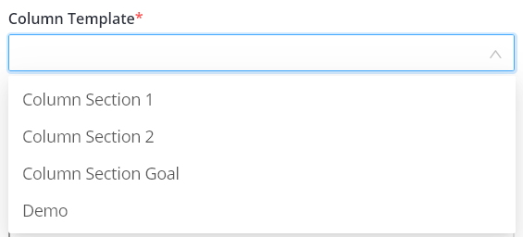

* Checkbox “General” means current section will be the same for all of employees (checked) or different for each employee (unchecked). Hover into  icon for more information or see explanations below.

If it will be the same for all of employees (checked), then the one setting up template must set up this section (fill in criteria, proportions, …) before sending current template for approval.

If it is different for each employee (unchecked), then current section will be closed for current status and only open for appraisers to fill in information (criteria, proportions, …) for each specific employee when the form is in verifying state.

* Checkbox “Overall” defines current section contains overall section or not. Section overall is for participating employees and users to comment and displaying overall rating in current form. Hover into  icon for more information.

Section overall only generate when the template is in “Verifying” state or higher. Section overall contains text input boxes for appraisers, appraisee and client to comment by default.

When the form is in “Finalizing” or “Reviewing” state (at this point, the form contains rating from both side), section overall will generate a table to calculate scores, comparing to last review performance scores.

* “Description” field contains of description of current section.
* If you want to change sections order, just grab the title and drag it in desired position. See the example below.
* For example, we will create three sections with information like these.
* Section 1. The title is “SECTION 1: PERFORMANCE APPRAISAL”.

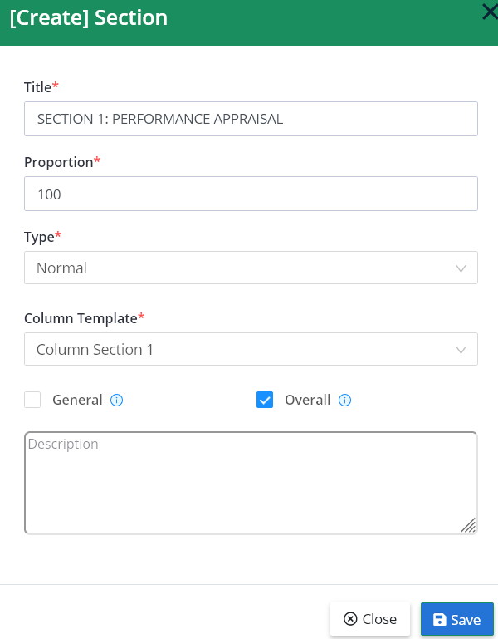

* Section 2. The title is “SECTION 2: OPINIONS OF APPRAISEE ABOUT TEAMLEADER, OTHER MEMBERS AND COMPANY”

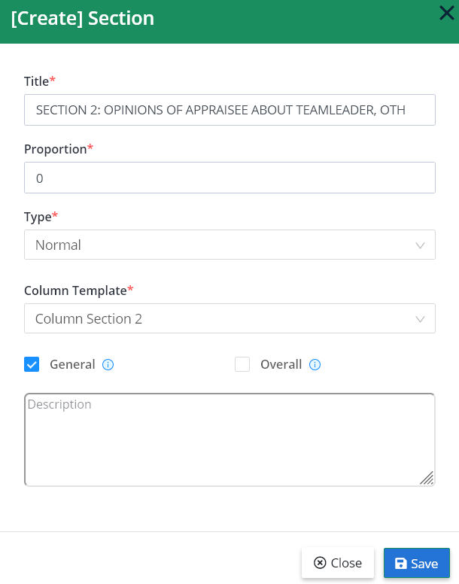

* Section 3. The title is “SECTION 3: PERSONAL DEVELOPMENT PLAN- NEXT GOALS”.

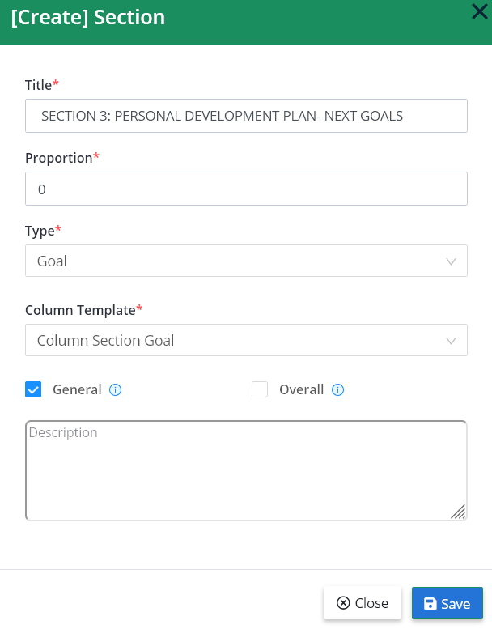

* The proportion for parent sections are not necessary, we can choose any numbers but the total must be 100%, so we choose section 1 is 100%, section 2 is 0% and section 3 is 0%.
* The reason that section 1 has “General” field unchecked is because this section contains multiple subsections (children sections, see 6.6) and we are not going to set up criteria for this parent section.
* After creating those sections, the result looks like the images below. Every sections will have their own information section to display information of them.

Section 1:

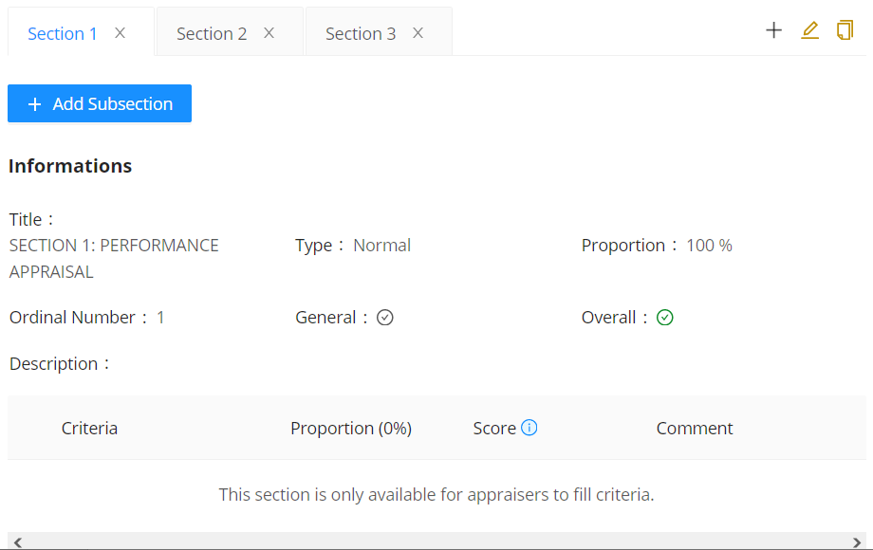

Section 2:

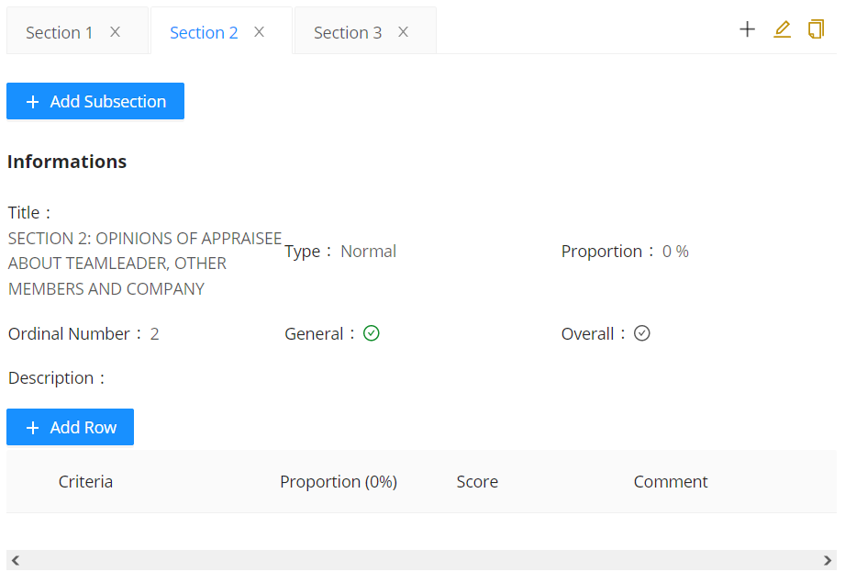

Section 3:

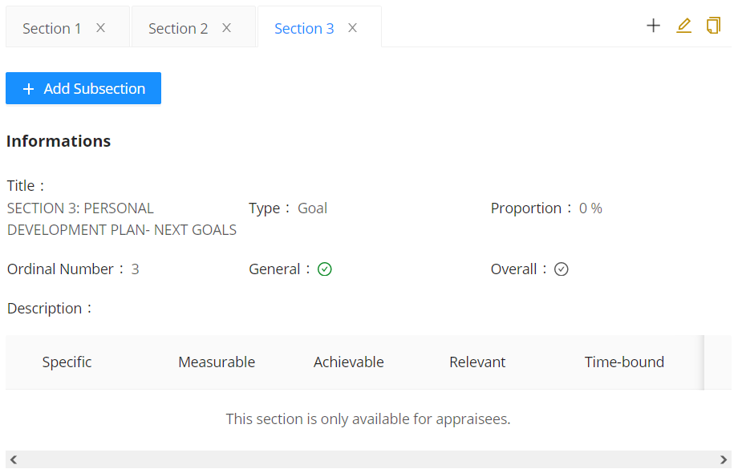

* The text “This section is only available for appraisers to fill criteria.” indicates that current section is closed until the form uses this section is in “Verifying” state (see 6.7).
* The text “This section is only available for appraisees.” indicates that current section is closed until the form uses this section is in “Verified” state and only appraisees can add more rows into this section.
* If you want to change position of the section 1 to position of the section 2, click and hold on the title, then drag it in section 2.
* **Note**: the positions of section 1 and section 2 are swapped together, not moved around. For example, if you swap section 1 with section 3, those two positions are the only changed in the list, so the final position is: section 3, section 2, section 1 – instead of: section 2, section 3, section 1 (if they are moved).

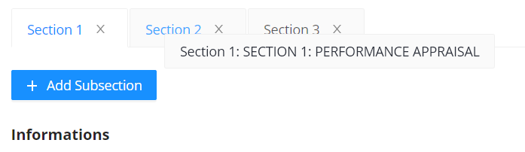

* Although the tabs’ titles don’t change, the contents inside are moved. Notice that the contents from section 1 are now in section 2 tab, and contents from section 2 are moved in section 1 in the image below.

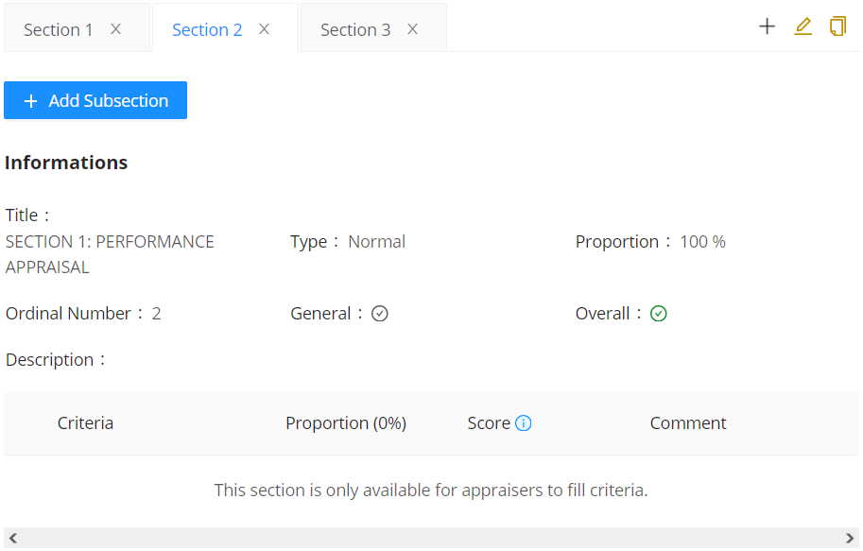

* This example is only for demonstrating how to reposition sections. We will move section 1 back to it original position.

## Create subsections

* To create subsections, simply click the “**+ Add Subsection**” button, an pop up will appear. This pop up is just like the pop up when we were creating section (see 6.5).

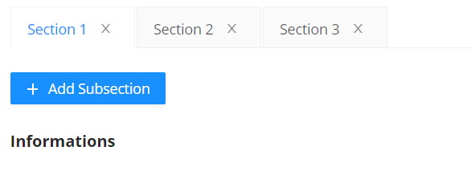

* In this example, we need four subsections for section 1, while section 2 and section 3 don’t need any subsection. All this subsections don’t contain any sub-subsection, so we uncheck the “Overall” checkbox.

Subsection 1: “JOB KNOWLEDGE”

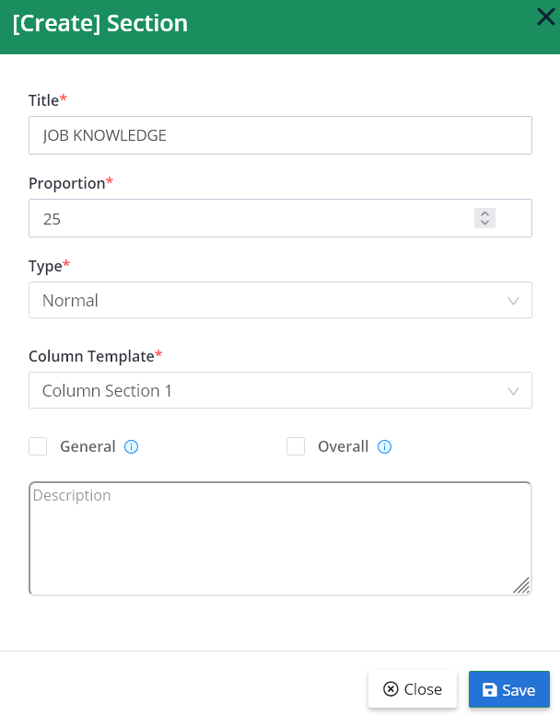

* This subsection is different from each employee because they have different skill sets. So uncheck the “General” checkbox to close this subsection until appraisers verify this form template.
* Beside of this subsection, other subsections will be checked “General” because they are the same for every employees, and they use the same set of criteria.

Subsection 2: “DELIVERY CONTRIBUTION”

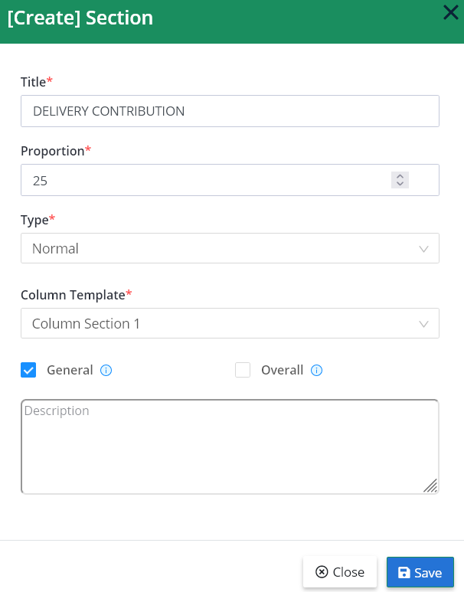

Subsection 3: “COMPETENCIES AND BEHAVIORS”

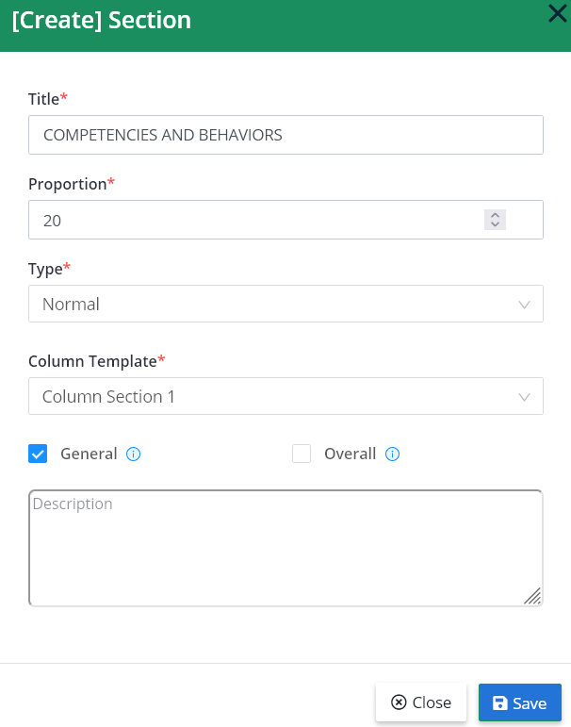

Subsection 4: “ENGLISH”

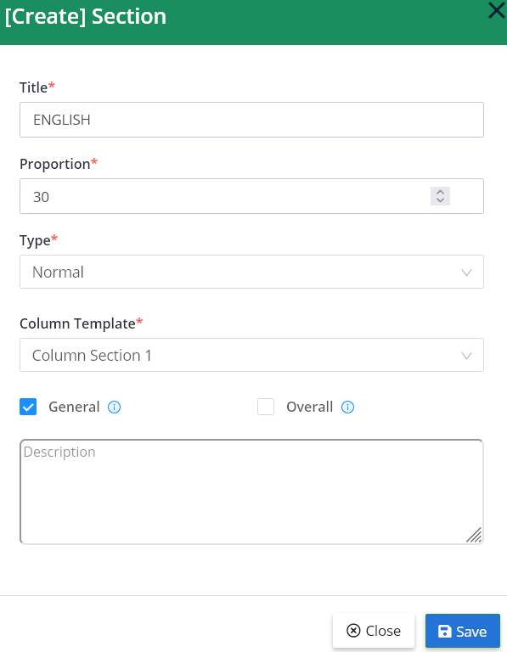

* After creating, the result looks like the image below. Please note that, for the sake of this image is the unrolled version from the web application.

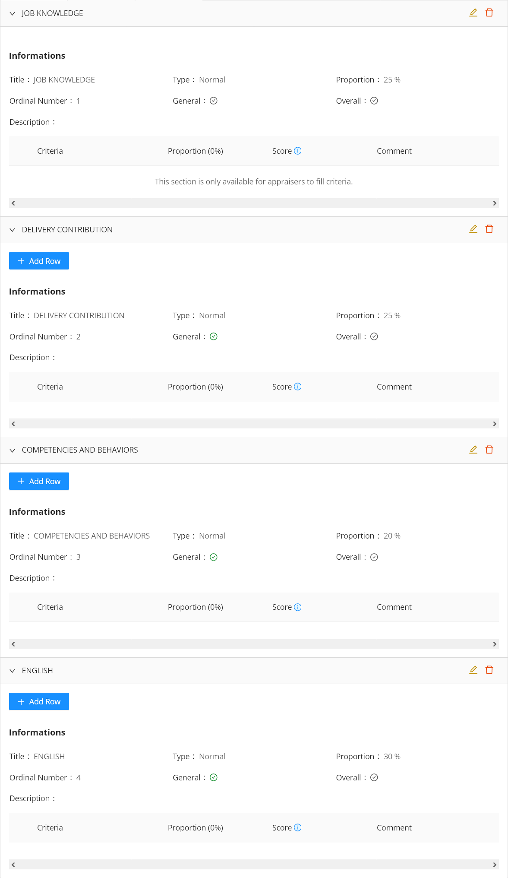

* Notice that only the subsection 1 is the one doesn’t have “**+ Add Row**” button, because the subsection is not “General”.
* The “Score” column has an information icon , it means that this column “Is Required” – require appraisers and appraisee input (see “Is Required” from section 5.3).
* If you want to change subsections’ positions, just grab the subsection’s title and drag it in to desired position.

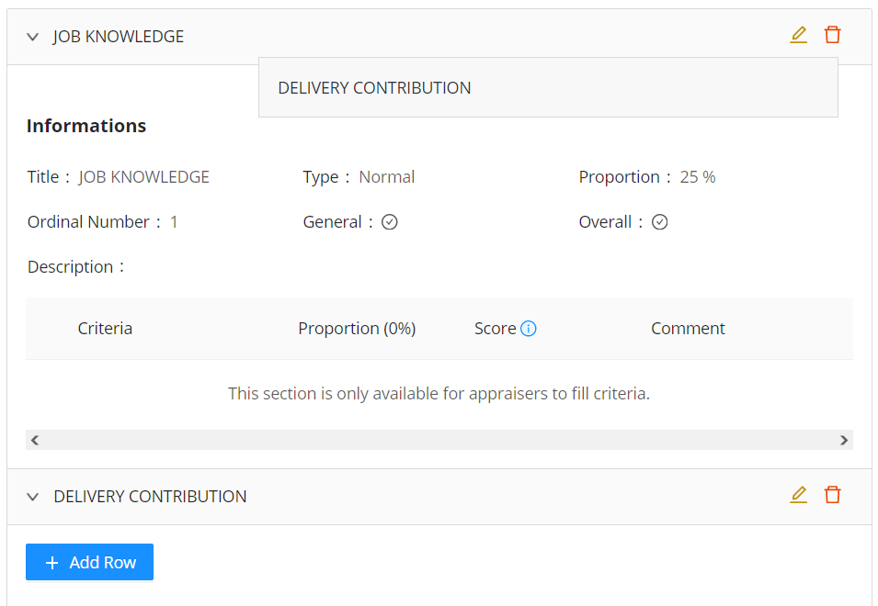

* Then the section “DELIVERY CONTRIBUTION” is moved to the top and

## Set up criteria

* To set up criteria, simply click “**+ Add Row**” and a new row is added to current section.
* The new row will have some textbox for columns which have “Fill Data” unchecked (see “Fill Data” from section 5.3).

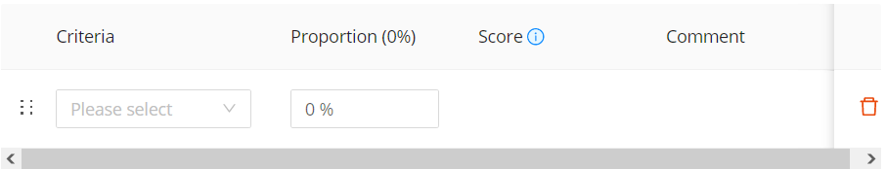

* Total proportions of every subsection must be equal to 100%. If not, there is a text on top of current subsection to remind “Please setup correct percent for each criteria”.
* For example, we create a row on subsection 2, then we fill criteria and proportion and add more rows if needed.
* Current subsection use column template “Column Section 1” which looks like this on column template page:

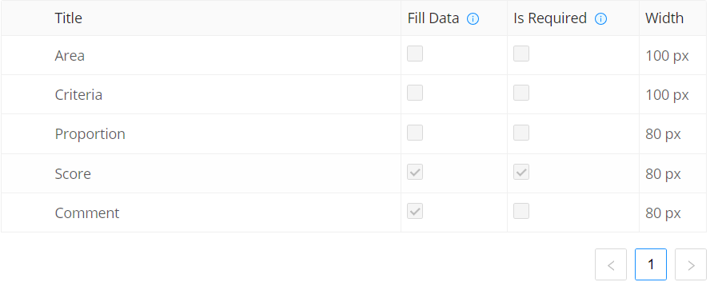

* “Area” and “Criteria” column is a set from “Performance Skill” criteria type, which looks like the image below. It has max criteria level is **2** then the system will generate **2** columns for this criteria (see “max criteria level” from 4.3).

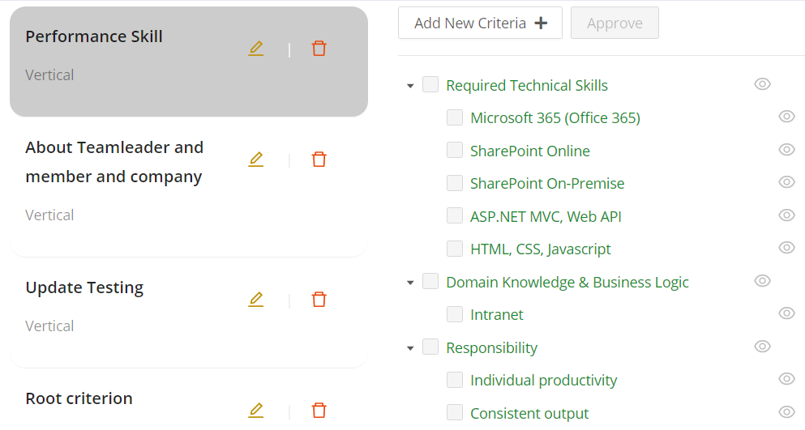

* If you select the criteria, the system will show criteria like below:

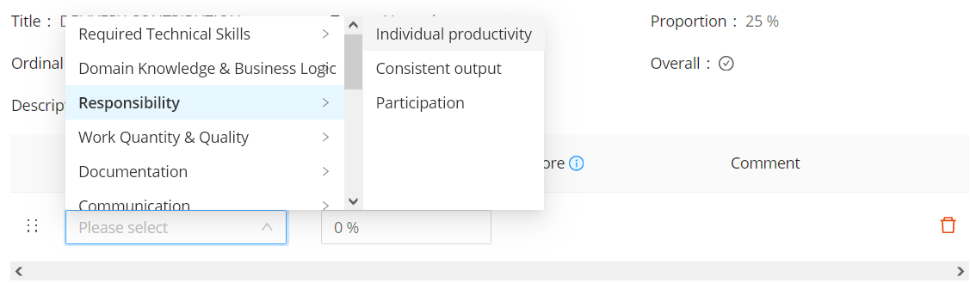

* Notice that the criteria type now separated into its max-criteria-level columns. We only need to display child criteria, because when you select the child criterion, you already select all the criteria from the root criterion to current child criterion, for the sake of simplicity.
* The system will properly expand to its max-criteria-level columns when in reviewing.
* For example, we will create some random criteria for subsection 2 “DELIVERY CONTRIBUTION”.

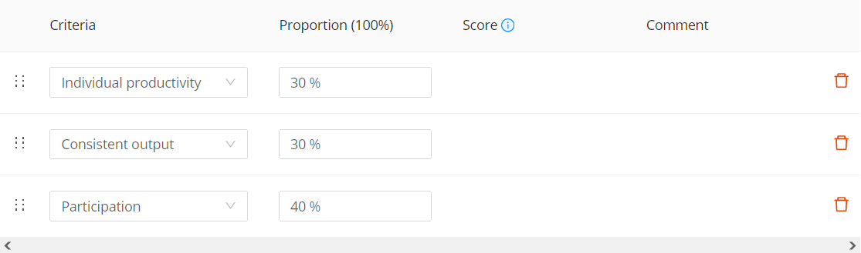

* To delete a row, just click on icon delete  and click “**OK**” to confirm.

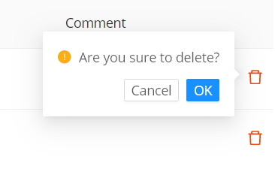

**2**

**1**

* To change position of a row, grab on the 6-dots icon next to criteria input box and drag it in to desired position.
* For example, we grab “Participation” into “Individual productivity”.

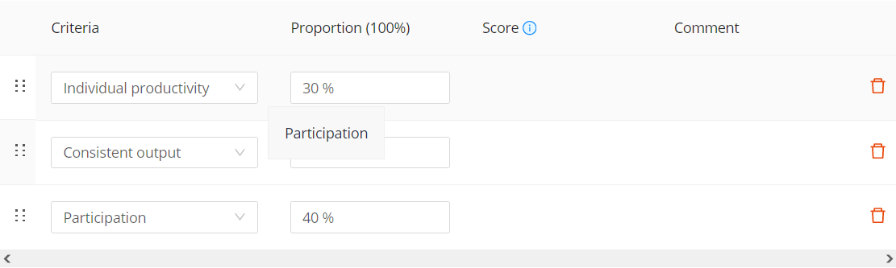

* Then “Participation” will be moved to the top and push others to the bottom.

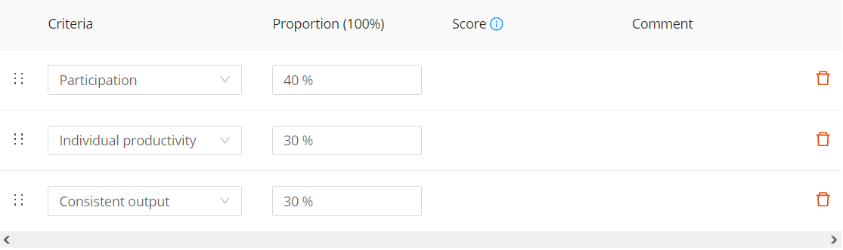

## Update and delete a section

* To update section, click on edit button , then a pop up will appear.

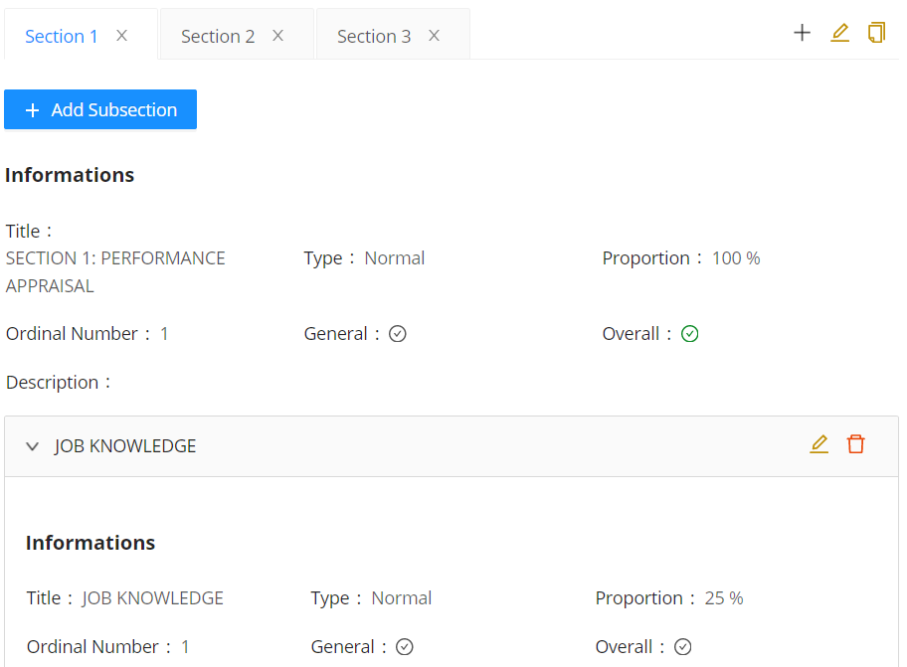

* The button  on the level of tab title will edit the parent section, the button  on the level of the subsection titles will edit that subsection.
* The “**Update**” pop up for updating parent section is almost identical to the “**Create**” pop up, except it doesn’t have a dropdown to choose column template. Because this section contains subsections, so you don’t need to choose a column template. The pop up looks like this:

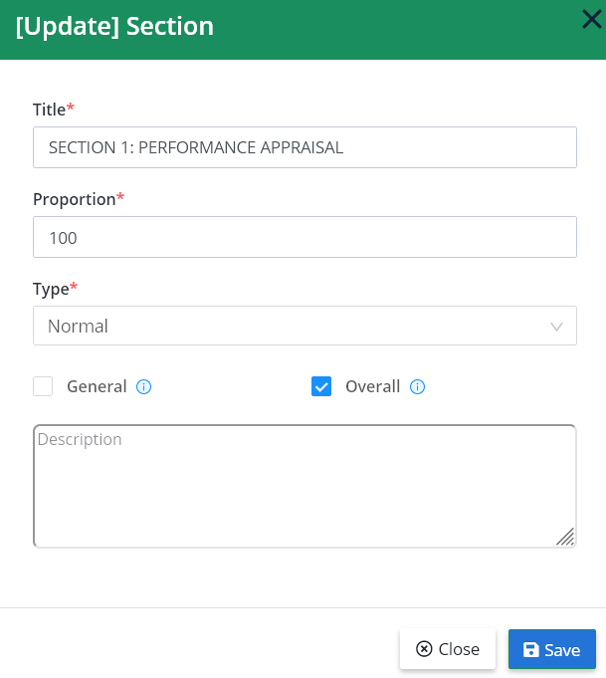

* The “**Update**” pop up for updating subsections is identical to the “**Create**” pop up. There is a dropdown to change column template. If you change to another column template, a confirmation pop up will appear to warning that the system will delete all current rows of this subsection. Click “**OK**” to confirm.

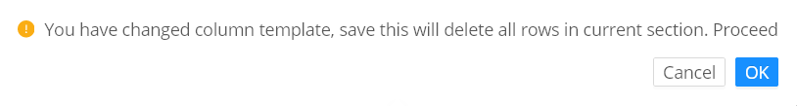

* **Note**: delete a section or subsections will also delete all of its contents including subsections (if available).
* To delete a parent section, click button  on the section tab, then click “**OK**” to confirm.

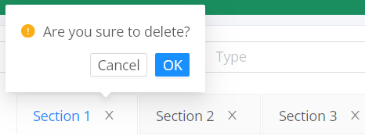

* To delete a subsection, click on delete button  on the level of the subsection’s title. Then click “**OK**” to confirm.

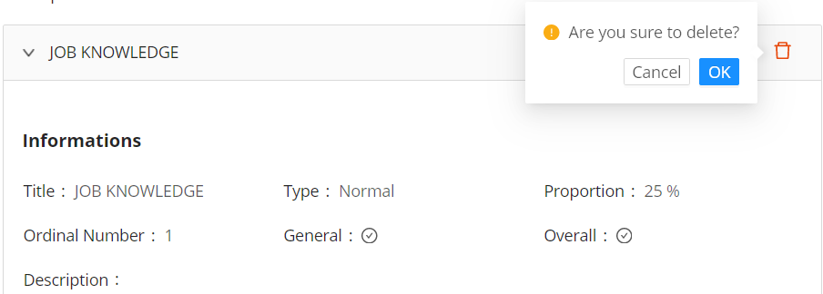

## Update and delete template

* To update template, click on the edit button  then click “**Update**” to save changes.

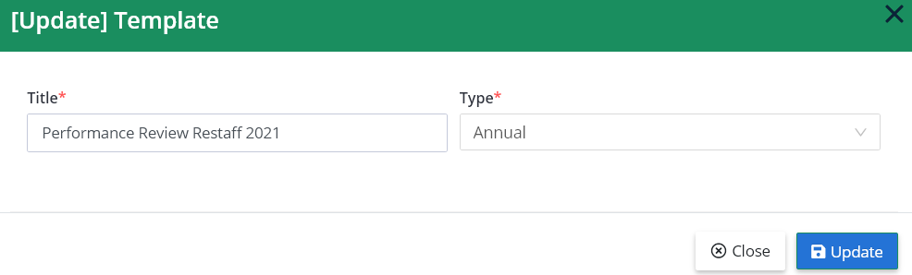

* To delete a template, click on the delete button , then click “**OK**” to confirm.

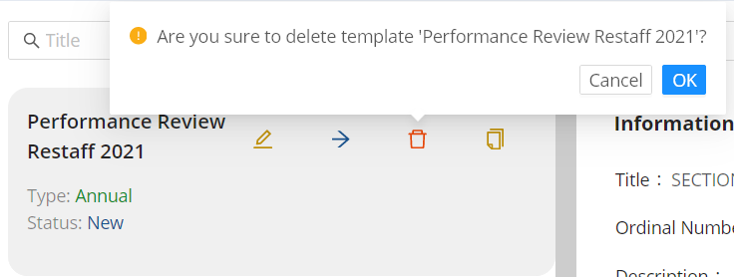

## Approve and reject template

* To make a template to be available to use in review performance period, it must be approved. To get approval, the template must be send first. To send for approval, click on the send button , then a pop up open displaying a preview of current template, then click “**Send for approval**” to confirm (the image is too long so we cut off the content in the middle).

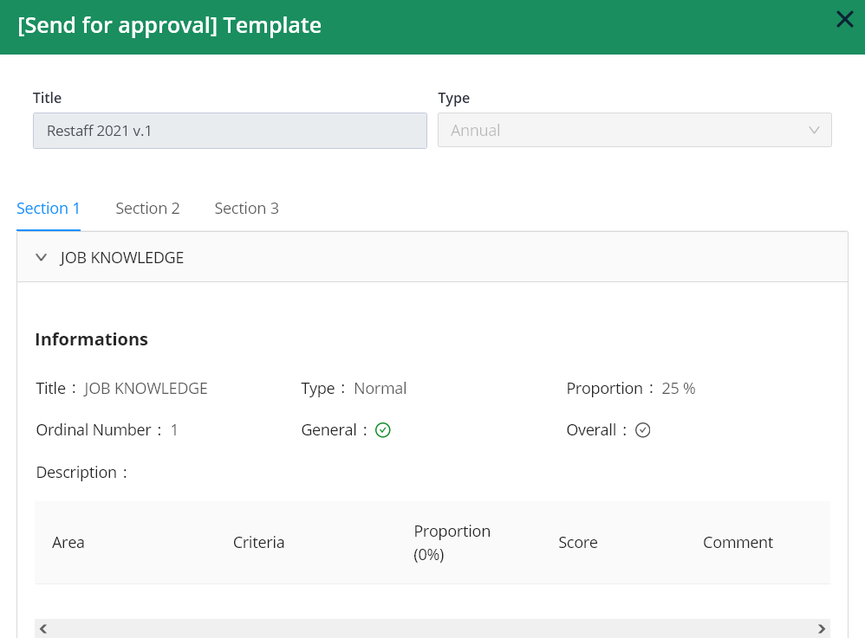

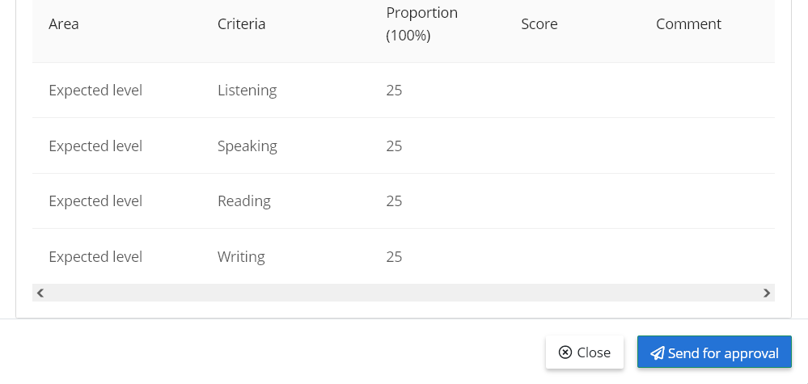

* Only templates that have been set to valid proportions (100% in total) in every sections will be able to send for approval.
* After click “**Send for approval**”, all the users who have “**Approve**” or “**Reject**” permission will be notified (see 6.1). The template after “**Send for approval**” action.

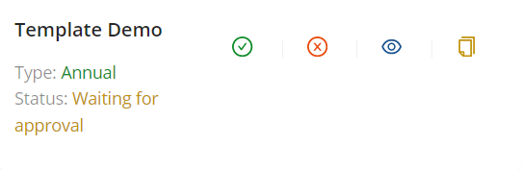

* To approve, click on approve button , a pop up for previewing will appear. Click “**Approve**” to confirm.

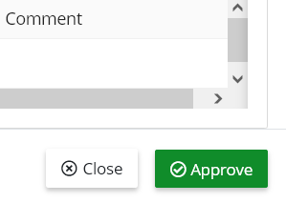

* An **approved** template will be available to use when creating form review. Also a notify to all employees who have “**Send For Approval**” permisison.
* To reject, click on reject button , a pop up for previewing will appear. Click “**Reject**” to confirm.

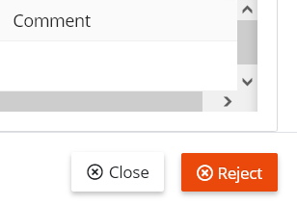

* When reject a template, also a notify to all employees who have “**Send For Approval**” permisison.

## Set up rating details

* To set up rating details for current template, click the view details button  - only approved templates are able to set up rating details.

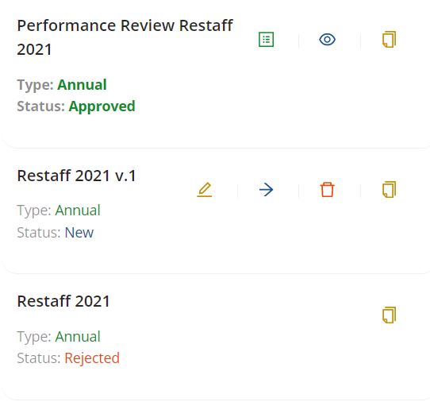

* There are three sections in setting up rating details page: “Information” section, “Sections And Ratings Detail” section, “Sections And Column Definition” section.
* Section “Information” is for displaying current template’s information.
* Section “Sections And Ratings Detail” is for setting up description for each rating in each criterion. The unchecked “General” subsections are only have on row because each employee has different set of criteria, so we only need one row to describe rating guideline.
* Section “Sections And Column Definition” is typically for describing columns section type goal (see 6.5).

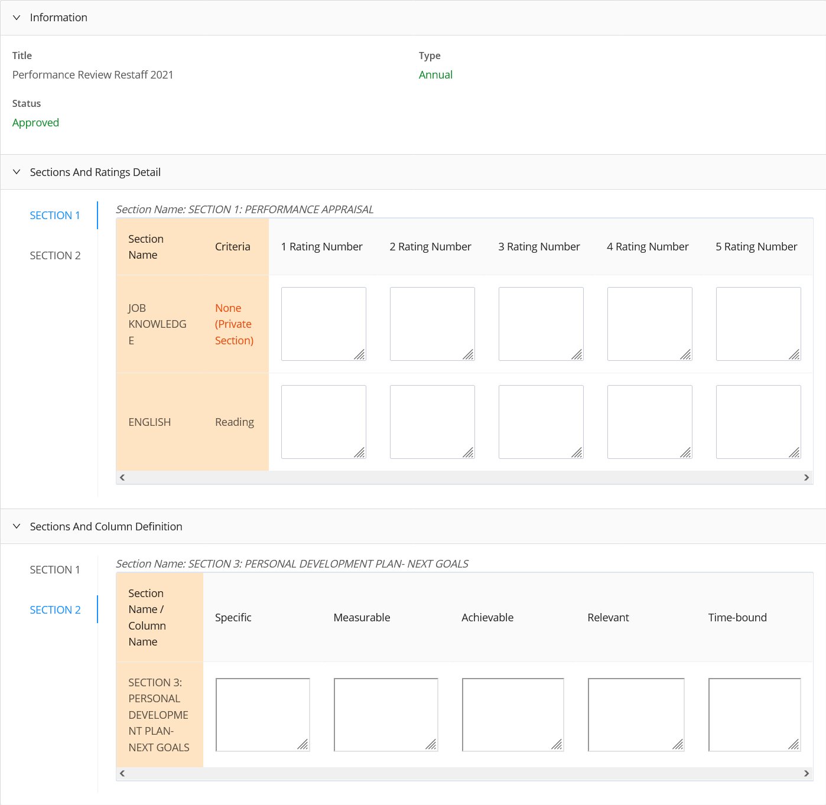

* All the textboxes have auto-saving feature, just typing and they are all done.

# Manage forms

## Page permission

* Line 1
* Line 2

## Main page

* Line 1
* Line 2

## Create new form

* Line 1
* Line 2

## Add members to form

* Line 1
* Line 2

## Review members

* Line 1
* Line 2

## Reject and complete form

* Line 1
* Line 2